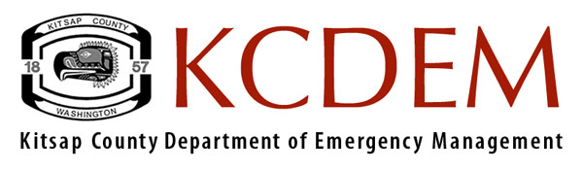
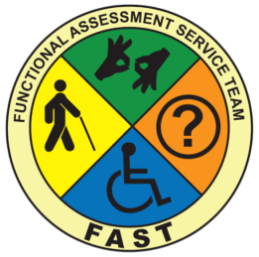
Functional Assessment Service Teams (FAST)
FACTS

People with access and functional needs can (and must) be accommodated in general population emergency shelters when given the proper support. Meeting the needs of people with access and functional needs requires proper planning pre-incident and proper coordination during the incident. Support for this comes from government, non-governmental organizations, and private sources. Functional Assessment Service Teams (FASTs) will help assess people with access and functional needs and assist them by getting them what they need to stay in a shelter.

Overview of FAST

Developed in California in 2006, Functional Assessment Service Teams (FASTs) are teams of trained people ready to respond to work in emergency shelters. FASTs work with emergency shelter personnel to conduct assessments for people with access and functional needs in community and American Red Cross emergency shelters. FASTs are deployed as the shelters open and work until no longer needed, or they may support several shelters. Using their expertise and knowledge, FASTs support the process of acquiring potential resources for people with access and functional needs. These resources may include durable medical equipment (DME), consumable medical supplies (CMS), essential medications, communication access and personal assistants. FAST members must possess the knowledge, skills and abilities to work in their area of specialty, and have an in-depth knowledge of populations they serve, their cultures, and service networks.

A fully staffed FAST has members with experience in the following areas:

- Aging (services/supports)
- Chronic health needs
- Developmental and other cognitive disabilities (i.e. traumatic brain injury)
- Hearing loss
- Vision loss
- Mental health disabilities
- Physical disabilities
- Substance abuse issues
FAST Members Experience
Members should have a combined experience working with people who have/are:

- Mental health issues
- Developmental and other cognitive disabilities
- Low vision/blindness
- Deaf/hard of hearing
- Aging
- Chemical dependencies
- Physical health conditions (nursing support services)
- Physical disabilities

TRAINING
All FAST team members will receive training. Training will include:
- Length: 16 hours over two consecutive days
- Number of participants for each session: target is 40
- Trainers represent a variety of disciplines
- Department of Homeland Security approved

